UK Health Security Agency South West  3rd Floor, 2 Rivergate  Temple Quay, Bristol, BS1 6EH  Follaton House, Plymouth Road, Totnes, Devon TQ9 5NE |  | T +44 (0)300 303 8162  swhpt@phe.gov.uk  www.gov.uk/government/organisations/uk-health-security-agency

30 July 2026

Dear Parent or Guardian,

I am writing to inform you that a child from the school has been admitted to hospital with meningitis, probably caused by the meningococcal bacteria.

There is no reason to make any change in the school routine and no reason for children to be kept at home.

Meningococcal bacteria are carried in the back of the throat of about one in ten people at any one time, but only very rarely cause illness. Most people who carry the bacteria become immune to them. The bacteria do not spread easily and only those who have had prolonged, close contact with the person are at a slightly greater risk of getting ill. These people have been identified by the UKHSA South West Health Protection Team and offered antibiotics to reduce the chances of the bacteria spreading. Others who attend the school have a very low risk of developing meningococcal disease and no further wider action is necessary at the present time.

Although the risk of another case in the school is very small, it is sensible to be aware of the signs and symptoms which are detailed below. Also, some people may experience diarrhoea and vomiting.

Meningitis Septicaemia
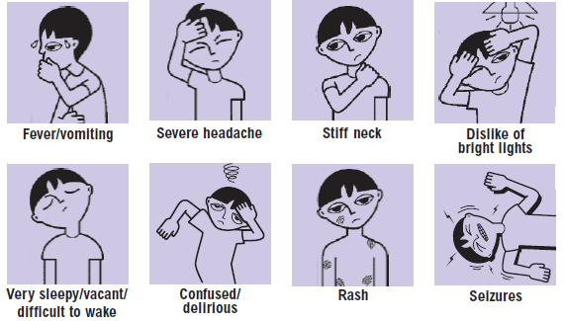
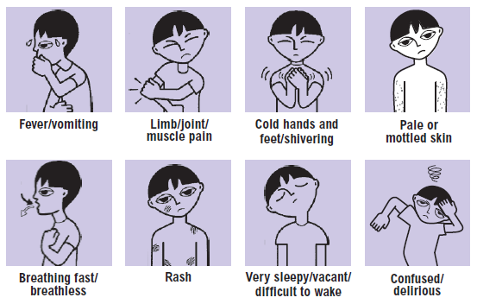

Reproduced with kind permission of Meningitis Research Foundation © Meningitis Research Foundation

NOT ALL OF THESE SIGNS AND SYMPTOMS MAY SHOW AT ONCE, but someone with this illness will become very ill. The illness may progress over one or two days, but it can develop very rapidly, sometimes in a matter of hours. Very young infants may also refuse feeds and have a high pitched cry. They may also appear floppy and have a tense and bulging spot on the head (known as a bulging fontanelle)

Diagnosis in the early stages can be difficult. The early signs can be like bad ‘flu’ symptoms but be WATCHFUL and use your instincts. If someone becomes ill with some of these signs or symptoms, contact the doctor urgently and ask for advice or call 999 anytime if you feel their condition is life-threatening or very serious.
For non-urgent advice out of hours call NHS 111.

We do recommend that your child/children are up to date with their routine childhood immunisations/vaccinations, including those which offer protection against some strains of the meningococcal bacteria. Your GP or practice nurse can advise if you’re not sure.

Further information is available from:

The Meningitis Research Foundation: www.meningitis.org, 0808 800 3344

 or scan here if you have a Smart phone

Meningitis Now: https://www.meningitisnow.org, 0808 80 10 388 (9am-5pm)
If you have any questions please call the Health Protection Team on 0300 303 8162.

Yours sincerely,
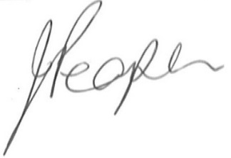

Head Teacher

