What is it like to be brought up in a Jewish home in the UK today?
Ash Class RE • Knowledge Organiser
What I already know  • People have different beliefs.  • Families have special traditions. | What I will know by the end  • Jewish families celebrate Shabbat.  • The Torah is a special Jewish holy book.  • Some Jewish homes have a mezuzah.  • Jewish families celebrate in different ways.
Top 6 words
Judaism – The Jewish religion. | Jewish – A person connected to Judaism.
Shabbat – A special weekly day of rest. | Torah – The Jewish holy teaching and scroll.
Synagogue – A Jewish place of worship. | Mezuzah – A small case with a prayer, fixed to a doorpost.
Jewish life at home and in the community
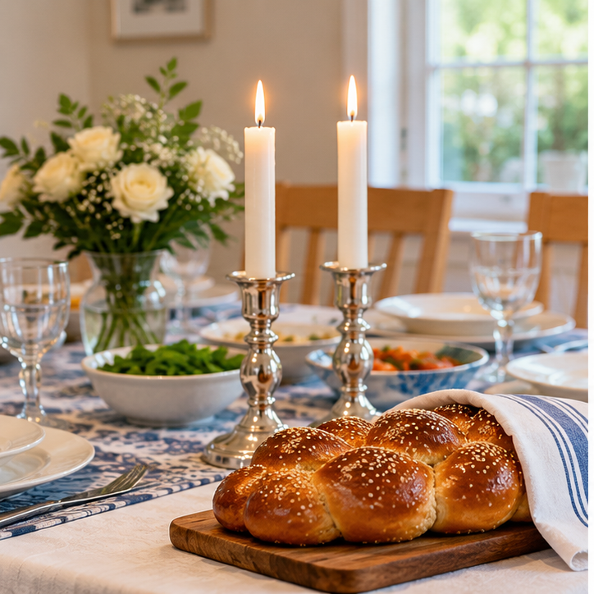 | 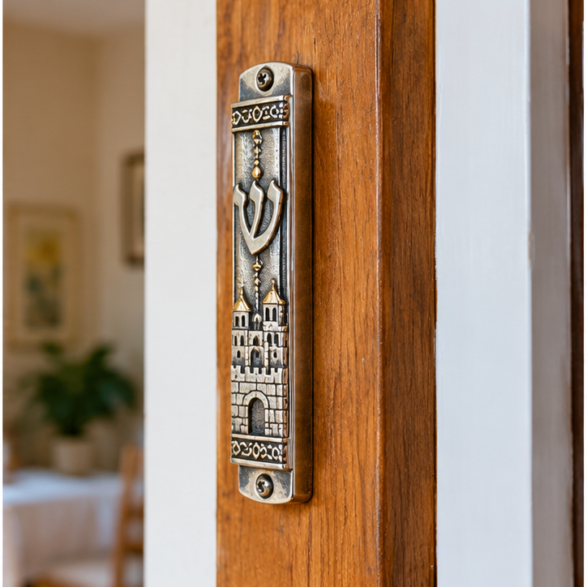 | 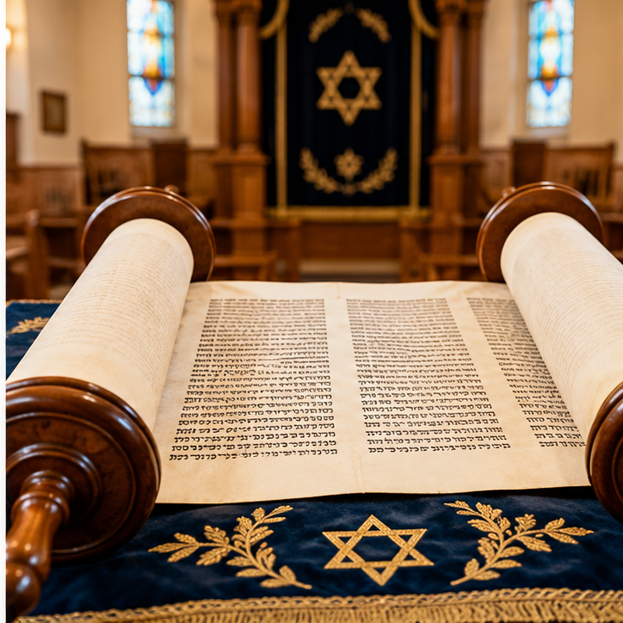
Shabbat  Family time, candles and challah bread | Mezuzah  A special case on a doorpost | Torah  A holy scroll used in worship

