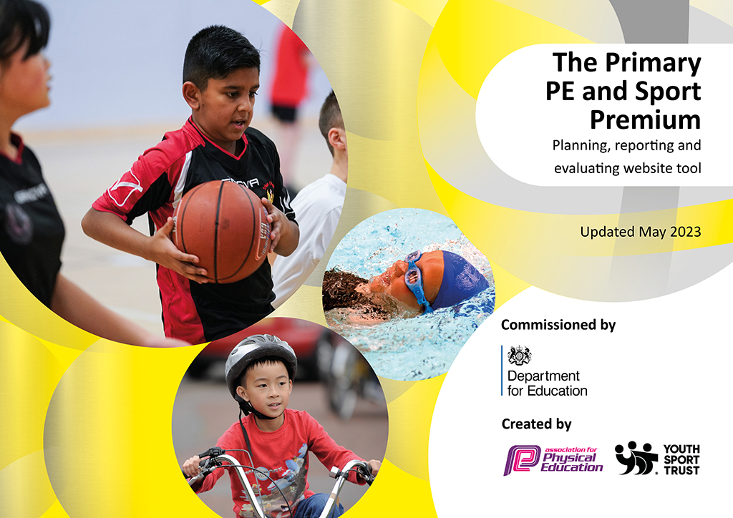
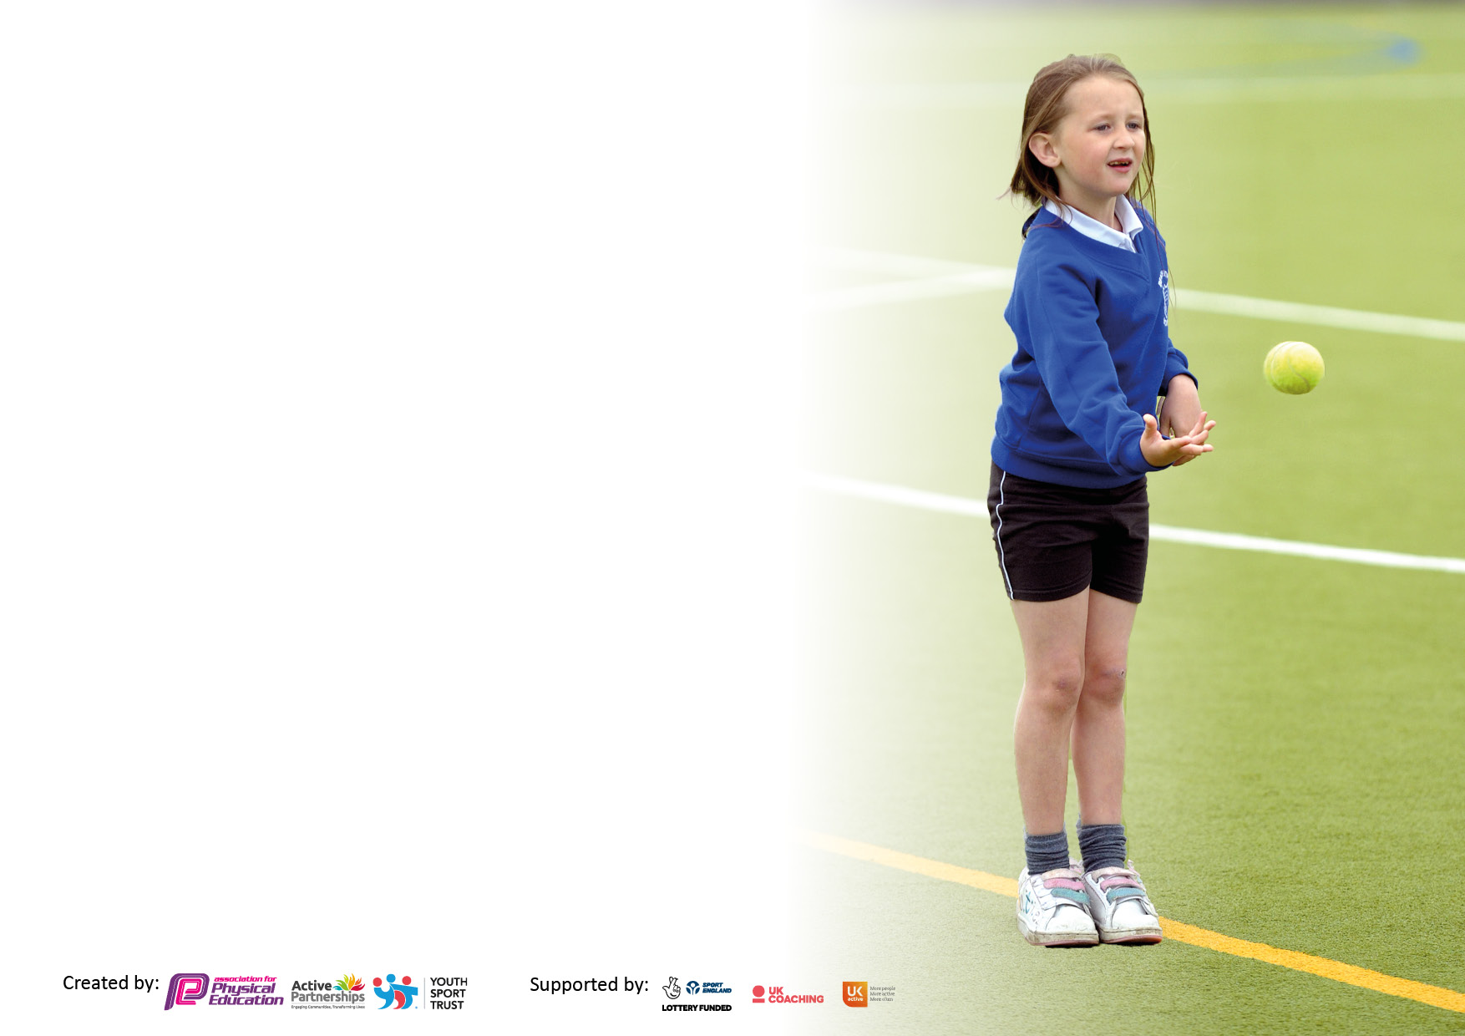

It is important that your grant is used effectively and based on school need. The Education Inspection Framework makes clear there will be a focus on ‘whether leaders and those responsible for governors all understand their respective roles and perform these in a way that enhances the effectiveness of the school’.

Under the Quality of Education Ofsted inspectors consider:
Intent - Curriculum design, coverage and appropriateness
Implementation - Curriculum delivery, Teaching (pedagogy) and Assessment
Impact - Attainment and progress

To assist schools with common transferable language this template has been developed to utilise the same three headings which should make your plans easily transferable between working documents.

Schools must use the funding to make additional and sustainable improvements to the quality of Physical Education, School Sport and Physical Activity (PESSPA) they offer. This means that you should use the Primary PE and sport premium to:

- Develop or add to the PESSPA activities that your school already offer
- Build capacity and capability within the school to ensure that improvements made now will benefit pupils joining the school in future years
- The Primary PE and sport premium should not be used to fund capital spend projects; the school’s budget should fund these.

Pleasevisitgov.ukfortherevisedDfEguidanceincludingthe5keyindicatorsacrosswhichschoolsshoulddemonstrate animprovement.Thisdocumentwillhelpyoutoreviewyourprovisionandtoreportyourspend.DfEencouragesschools to use this template as an effective way of meeting the reporting requirements of the Primary PE and Sport Premium.

We recommend you start by reflecting on the impact of current provision and reviewing the previous spend.

Schools are required to publish details of how they spend this funding, including any under-spend from 2021/2022, as well as on the impact it has on pupils’ PE and sport participation and attainment. All funding must be spent by 31st July 2023.

We recommend regularly updating the table and publishing it on your website throughout the year. This evidences your ongoing self-evaluation of how you are using the funding to secure maximum, sustainable impact. Final copy must be posted on your website by the end of the academic year and no later than the 31st July 2023. To see an example of how to complete the table please click HERE.
Created by: Supported by:

Details with regard to funding
Please complete the table below.

Total amount carried over from 2021/22 | £0
Total amount allocated for 2021/22 | £17,380.00
How much (if any) do you intend to carry over from this total fund into 2022/23? | £0
Total amount allocated for 2022/23 | £17,440.00
Total amount of funding for 2023/23. To be spent and reported on by 31st July 2023. | £17,440.00
Swimming Data
Please report on your Swimming Data below.

Meeting national curriculum requirements for swimming and water safety.

N.B. Complete this section to your best ability. For example you might have practised safe self-rescue techniques on dry land which you can then transfer to the pool when school swimming restarts.
Due to exceptional circumstances priority should be given to ensuring that pupils can perform safe self rescue even if they do not fully meet the first two requirements of the NC programme of study
What percentage of your current Year 6 cohort swim competently, confidently and proficiently over a distance of at least 25 metres?  N.B. Even though your pupils may swim in another year please report on their attainment on leaving primary school at the end of the summer term 2022.  Please see note above | 79%
What percentage of your current Year 6 cohort use a range of strokes effectively [for example, front crawl, backstroke and breaststroke]?  Please see note above | 68%
What percentage of your current Year 6 cohort perform safe self-rescue in different water-based situations? | 68%
Schools can choose to use the Primary PE and sport premium to provide additional provision for swimming but this must be for activity over and above the national curriculum requirements. Have you used it in this way? | Yes

Action Plan and Budget Tracking
Capture your intended annual spend against the 5 key indicators. Clarify the success criteria and evidence of impact that you intend to measure to evaluate for pupils today and for the future.

Academic Year: 2022/23 | Total fund allocated: £17,440.00 | Date Updated: July 2023
Key indicator 1: The engagement of all pupils in regular physical activity – Chief Medical Officers guidelines recommend that primary school pupils undertake at least 30 minutes of physical activity a day in school |  |  |  |  | Percentage of total allocation:
 |  |  |  |  | 18.3%
Intent | Implementation |  |  | Impact
Your school focus should be clear what you want the pupils to know and be able to do and about  what they need to learn and to  consolidate through practice: | Make sure your actions to achieve are linked to your intentions: | Funding allocated: |  | Evidence of impact: what do pupils now know and what can they now do? What has changed? | Sustainability and suggested next steps:
To ensure that all pupils continue to achieve or surpass the recommended 90 minutes a week of PE through high quality lessons and active lunchtimes. | - Swimming lessons – Year 5 plus Year 6 non-swimmers  - PE sessions – (1 hour + 30 mins with FG)  - Playground Activities to include Active Playtime in KS1  - Daily Mile in EYFS and KS1  - Playtime leaders to support Active playtimes in KS1  - Lunchtime resources boxes in KS2  - Purchase of Basket Ball Posts  - After school clubs | Lunchtime sports coach £1500.00  Swimming intervention Y6 £500.00  PE equipment £800.00  Playground boxes and resources £400.00 |  | All children have taken part in 90 minutes of directed PE a week.  More children have engaged with lunchtime sports clubs. Including the preparation for sporting events and matches.  Increased number of pupils taking part in competitions, especially those who have not previously engaged.  SGO has organized a series of events across the school year that has targeted pupils who do not choose to take part in competitive sports.  Behaviour at playtimes improves when there are focused activities available to engage the children. Children have commented that it is nice to take part in sports activities other than football.  Lunchtime boxes continue to engage pupils and encourages them to undertake physical activity. | Continue to develop the role of playground leaders to support playtimes.  Maintain lunchtime provision and access to sports activities, particularly focusing on those pupils who do not attend after school clubs.  Maintain membership of the Forest of Dean Sports Partnership  Reinvigorate wake and shake across KS2.
Key indicator 2: The profile of PESSPA being raised across the school as a tool for whole school improvement |  |  |  |  | Percentage of total allocation:
 |  |  |  |  | 54.2%
Intent | Implementation |  |  | Impact
Your school focus should be clear what you want the pupils to know and be able to do and about  what they need to learn and to  consolidate through practice: | Make sure your actions to achieve are linked to your intentions: | Funding allocated: |  | Evidence of impact: what do pupils now know and what can they now do? What has changed?: | Sustainability and suggested next steps:
To target groups of pupils to improve outcomes, leadership, health and well-being | Sports coach employed to provide targeted interventions for identified pupils  Sports coach to deliver focused 30 minutes PE sessions to smaller groups of pupils (half a class) |  | Sports coach (interventions)  £2050.00  Sports coach PE Lessons £6,500.00  Lunchtime resources £300.00 | Targeting small groups of pupils has enables more focus to be put on the development of fundamental skills for all pupils. This has help to build skills and success which impacts positively on pupils confidence and well-being.  Greater numbers of children are keen to participate in games and competitions. | Maintain this approach as all children a access to a qualified sports coach.
2 sets of St John’s football kit purchased  PE kit continued to be purchased for school staff | Kit purchased for team games  Sports kit purchased for staff involved in teaching PE | Sports Kits £500.00  Hoodies and PE Kit £100 |  | Staff provided with kit where required  Staff to wear kit to sporting events  Children provided with kit when representing St John’s | To continue to provide kit for new members of staff.

Key indicator 3: Increased confidence, knowledge and skills of all staff in teaching PE and sport |  |  |  | Percentage of total allocation:
 |  |  |  | 1.7%
Intent | Implementation |  | Impact
Your school focus should be clear | Make sure your actions to | Funding | Evidence of impact: what do | Sustainability and suggested
what you want the pupils to know | achieve are linked to your | allocated: | pupils now know and what | next steps:
and be able to do and about | intentions: |  | can they now do? What has
what they need to learn and to |  |  | changed?:
consolidate through practice:
TAs to feel confident to support the delivery of fundamental movement lessons so that both staff and children have a positive experience of school PE. | TAs to support sports coach during PE lessons | £ See PE lessons | TA have developed the skills and knowledge to support fundamental skills lessons across the wider school | To continue next academic year
Provide ongoing CPD and support for all staff to ensure that all teachers/TAs deliver high quality PE lessons | TAs and CT to become more confident in supporting the delivery of swimming lessons  Further training and development opportunities to be explored. | £300.00 | Children become confident swimmers.  Staff are confidence in their support of pupils during swimming lessons. | Look for CPD opportunities
Key indicator 4: Broader experience of a range of sports and activities offered to all pupils |  |  |  | Percentage of total allocation:
 |  |  |  | 14.3%
Intent | Implementation |  | Impact
Your school focus should be clear | Make sure your actions to | Funding | Evidence of impact: what do | Sustainability and suggested
what you want the pupils to know | achieve are linked to your | allocated: | pupils now know and what | next steps:
and be able to do and about | intentions: |  | can they now do? What has
what they need to learn and to |  |  | changed?:
consolidate through practice:
All children to enjoy being physically active and develop physical literacy through participation in a broad range of structured and unstructured activities during extra-curricular time (Lunchtimes and break times)as well as organized events. | Employ external coach provision to provide extracurricular clubs after school x2 weekly  Children to attend a variety of events through the FOD sports club  - Archery  - Walk and Ride  - Building Confidence course  - Panathalon – SEND event  - Well-Being day  - Give it a go – for less active pupils  - 10 Pin Bowling  - Multi Sports | After school Sports coach £2050.00  Youth Sports Trust £450.00 | After school PE clubs took place for KS1 and KS2 across the year. Engaged children in PE and developed knowledge of rules, sportsmanship and playing team games.  A wide variety of sporting activities have been offered through the SGO this year to encourage all pupils, with a specific target on the less active. Children have taken part in archery, walk and ride, SEND sports, sporting leadership, Multi-sports.  Pupils experienced new sports, being active and what it feels like to take part in sports. | Continue members of FOD Sports Club  Continue with afterschool provision

Key indicator 5: Increased participation in competitive sport |  |  |  | Percentage of total allocation:
 |  |  |  | 11.4%
Intent | Implementation |  | Impact
Your school focus should be clear | Make sure your actions to | Funding | Evidence of impact: what do | Sustainability and suggested
what you want the pupils to know | achieve are linked to your | allocated: | pupils now know and what | next steps:
and be able to do and about | intentions: |  | can they now do? What has
what they need to learn and to |  |  | changed?:
consolidate through practice:
For pupils to participate in school sports competitions, both in house and with other schools | Children to attend following liaing with SGO and School Sports Partnership  - Girls’ Football tournaments  - Boys’ Football tournaments Years 3 / 4 and 5/6  - Cricket Competition  - Netball Competition  - School Sports Day  - Cross Country | Sports coach  £1544.00  Tournament Charges £446 | A number of tournaments have been entered and as a school we have enjoyed some success and at other times just enjoyed taking part and having a go. | Continue to be part of the School Games Partnership and Pr-stars sporting events. Join as many sporting events and competitions as is possibile in order to continue o strengthen PE at St John’s.

Signed off by
Head Teacher:
Date:
Subject Leader:
Date:
Governor:
Date:

