Would you prefer to live in a hot place or a cold place? GEOGRAPHY • KEY STAGE 1
What should I already know?  • Weather can be sunny, rainy, windy or snowy.  • The seasons change during the year.  • We can use maps and globes. | What will I know by the end?  • Where hot and cold places are.  • Where the Equator and Poles are.  • How people live in hot and cold places.

6 key words
Equator — An imaginary line around the middle of Earth. | North Pole — The northern end of Earth. | South Pole — The southern end of Earth.
Climate — The usual weather in a place. | Desert — A very dry place with little rain. | Polar — Near the North or South Pole.

Our world: hot and cold places
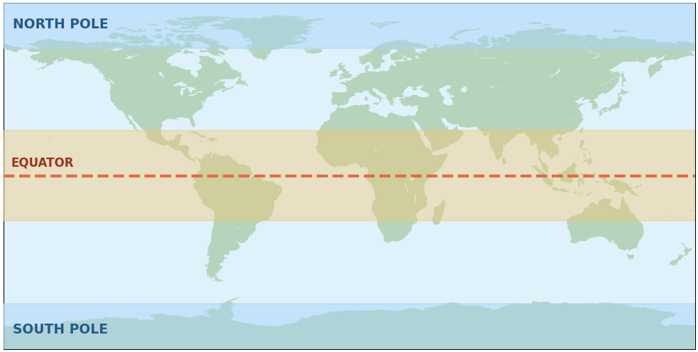 | HOT • near the Equator  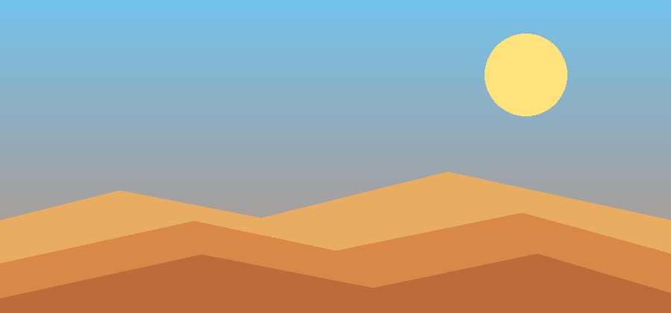  COLD • near the Poles  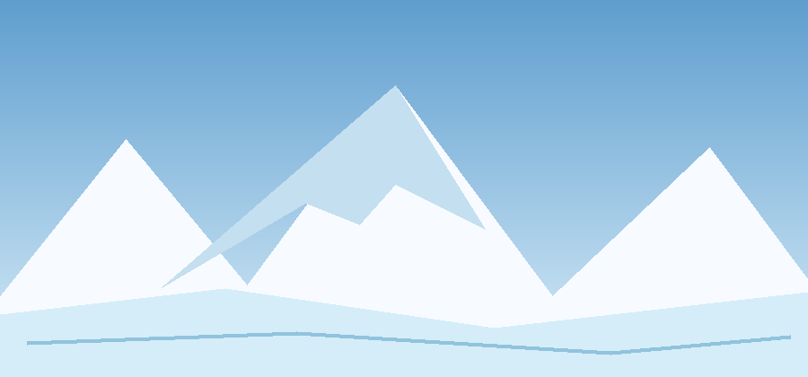
Map key: orange = generally warmer blue = very cold - - - = Equator Remember: Not all deserts are hot. The weather can change each day.

