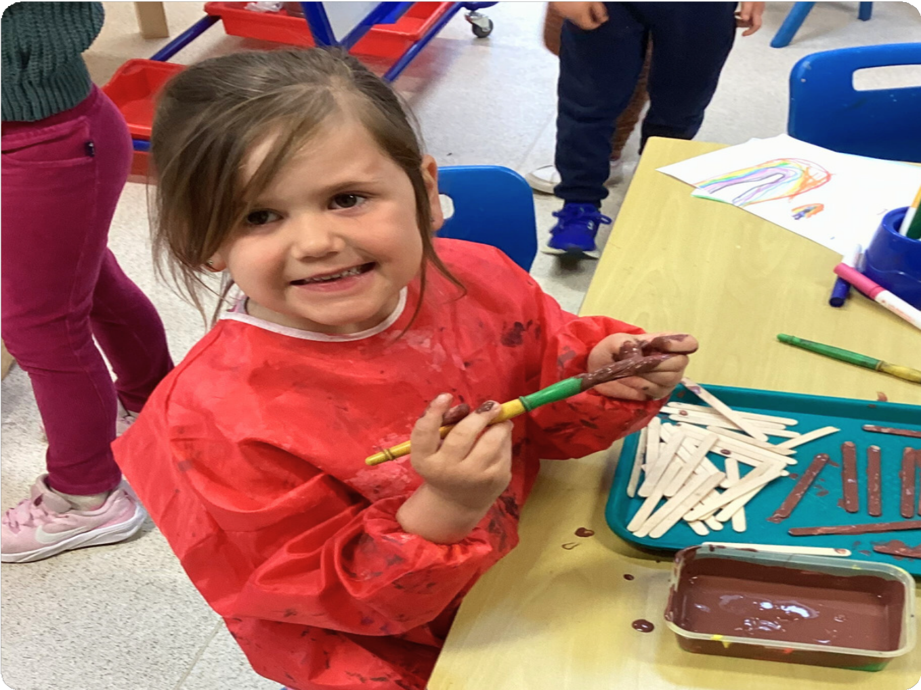

St John’s C of E Academy Primary School
Belonging, Believing, Becoming.

“St John’s is a very
supportive school with a lovely nurturing environment. Both my
children thoroughly enjoy their school experience!”
-Parent of the school

Welcome to St Johns ...
Welcome to St John’s Church of England Academy; a nurturing, safe and stimulating environment where everyone is valued. Our school is committed to making a difference to every child in our care. We aim to give our children the best start to their education, developing a love of learning and creating happy memories along the way as they grow into responsible members of society.

As part of the Diocese of Gloucester Academies Trust, our educational vision has a caring and supportive Christian ethos at its core. As a result of our Christian vision, pupils flourish regardless of any challenges they may face. Our staff team are committed to every child achieving to the best of their ability and flourishing in all aspects of their lives. We strive to be inclusive in all we do at St. John’s. Working closely with parents and carers, we make sure pupils are happy and safe and that they are achieving success in all areas of school life. We aim to enable every child at St John’s to flourish by encouraging their gifts and talents so they leave us believing they can achieve.

As a Church school, our curriculum is designed to present children with exciting learning opportunities, which motivate and inspire them, underpinned by our Christian values. We aim to provide our children with the skills, knowledge and values they may need as they continue their educational journey.

There is a powerful sense of belonging at St. John’s where both pupils and adults believe that they can become the best they can be. St John’s is a special school filled with caring people where children and adults are treated respectfully enabling them to grow and flourish.

Visits are encouraged and welcomed: we would be delighted to show you around our wonderful school.

We look forward to sharing this important period of your child’s life with you and hope that your association with the school is a long and happy one.
Mrs Emma Mignaud
Executive Headteacher

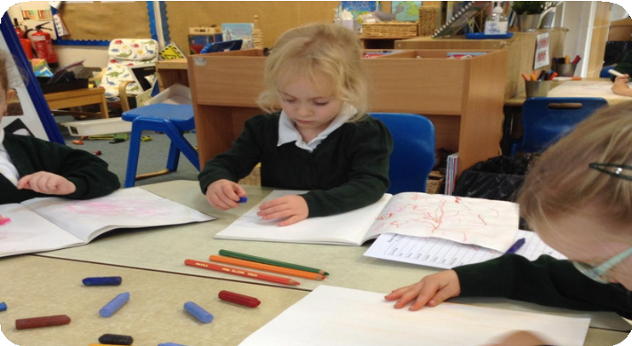
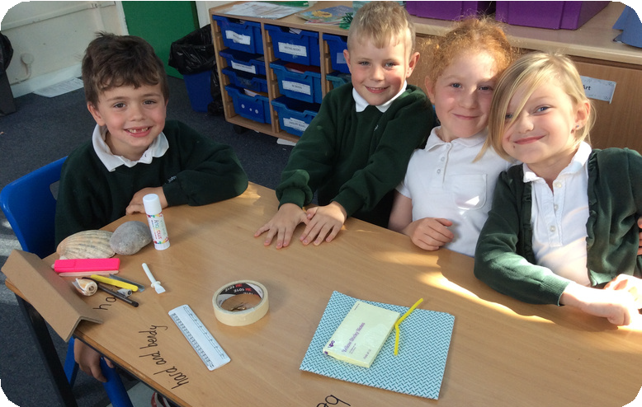
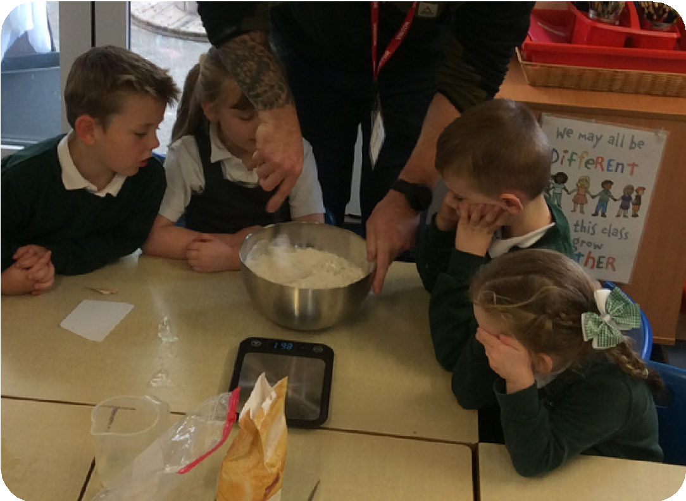


Class structure
Class structure is based on school numbers.
St John’s currently have 6 Classes: Rowan (Reception) Ash (Year 1)
Beech (Year 2)
Hazel (Year 3 and 4)
Elm (Year 4 and 5)
Oak (Year 5 and 6)

Curriculum
As a school, we meet all expectations of the National Curriculum for Key Stage 1 and Key Stage 2. For Reception Class we work to the Early Years Foundation Stage Framework.

Through the delivery of our curriculum, we aspire our children to grow our brains by being:
Brave Resilient
Inquisitive
Articulate

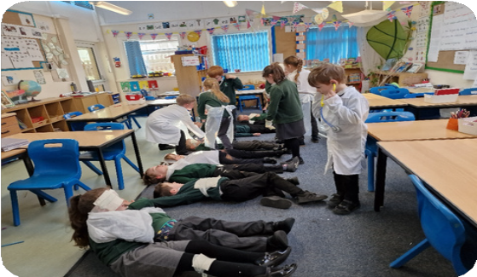
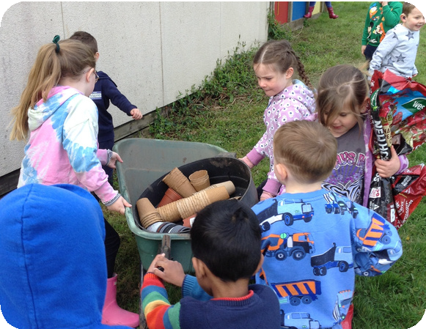


“They enjoy their time at
school. They make friends and learn happily together. Pupils are well cared for and safe.
They know that if they have any worries, staff will listen and help them”
-OFSTED report 2022

Vision and values
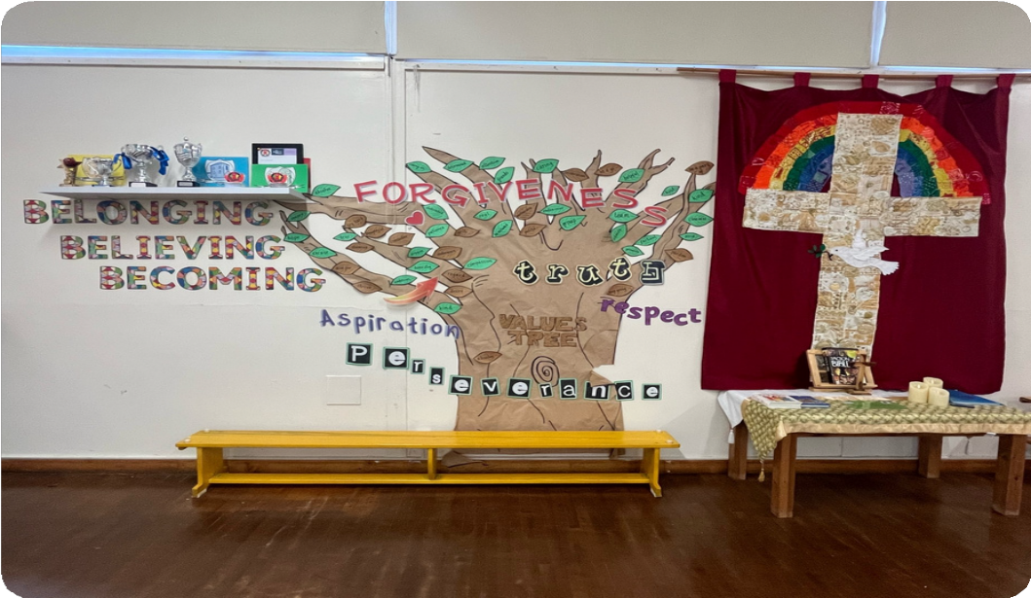
We believe that St John's Church of England Academy is a special place, and our shared Christian values are pivotal to this.

Our values are:
Perseverance Respect Forgiveness Truth Aspiration

Outdoor learning ...
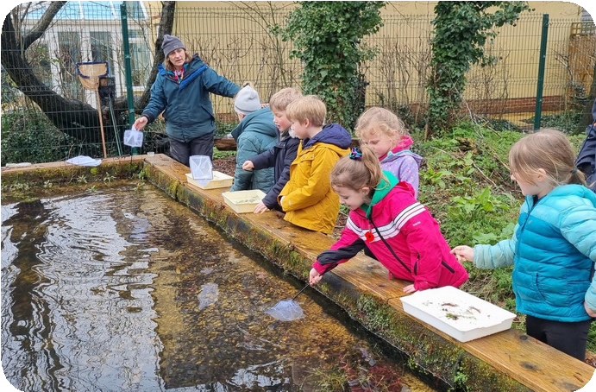
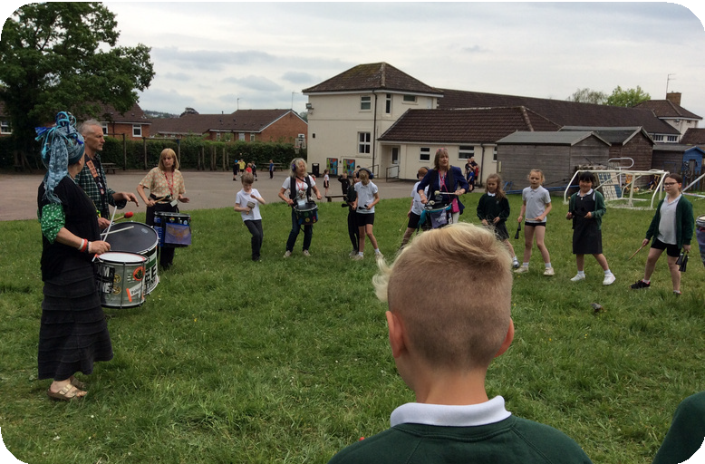
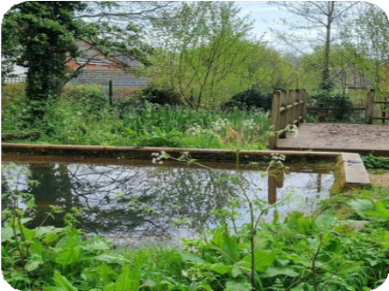
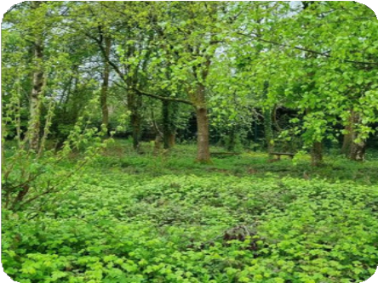
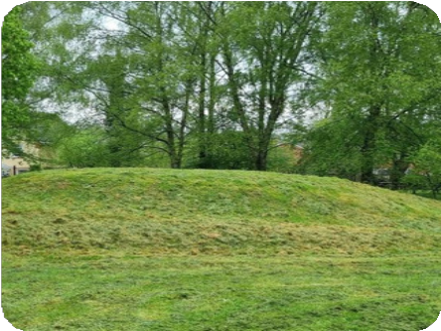
St John’s is grateful for the vast areas of outdoor space we have. Whenever possible, we look for opportunities to take learning outdoors, allowing children to gain hands-on experience and connect with the world around them.
Teachers create memorable experiences
that
inspire
curiosity
and
a
love
of
learning, contributing to a well-rounded
education.

“They are ‘relentlessly
bothered’ about their community. They ensure no one individual is left out and they strive to be inclusive in all that they endeavour to do”
-SIAMS report July 2024

Wraparound Care
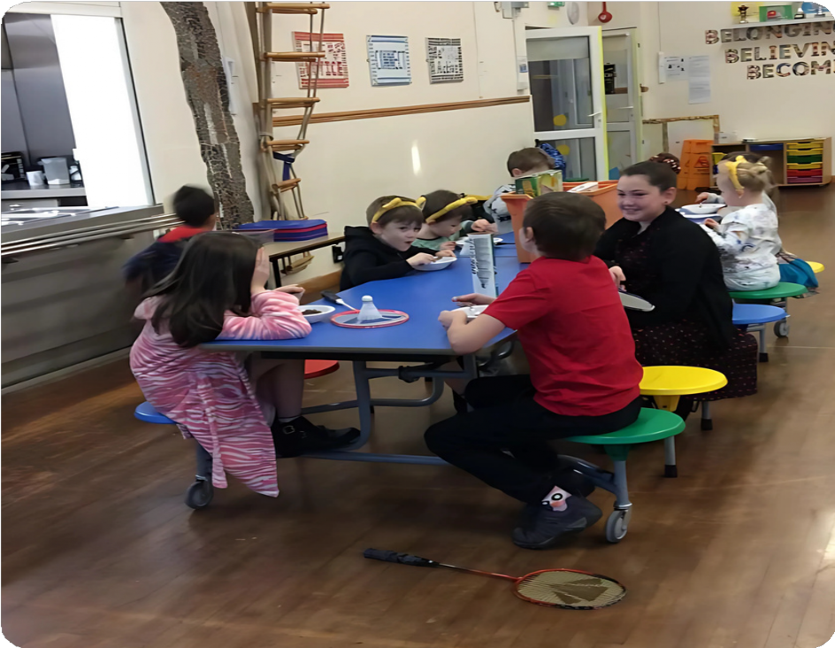

Breakfast Club runs from 7.45am each morning.
Cool Kids After School Club runs from 3.15pm – 5.30pm.
These sessions offer a safe happy and familiar environment with school staff making use of school facilities.

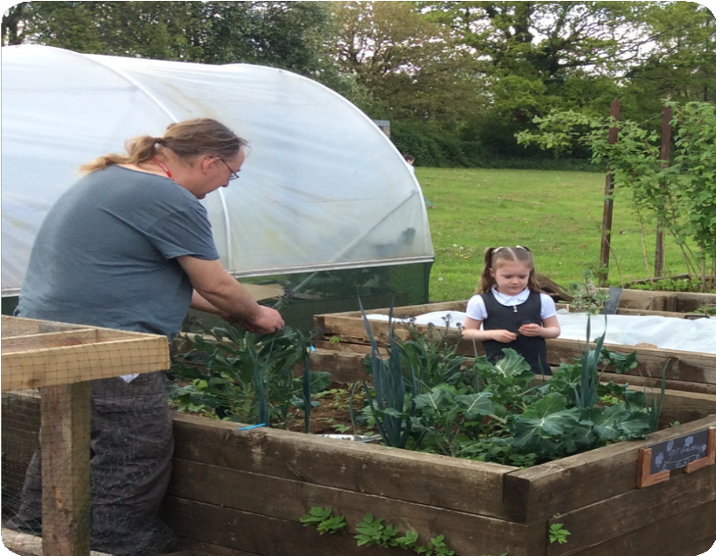


Extra-Curricular Clubs
At
St
John’s we
offer a rich and
varied selection of clubs within
school day
the
or
after school. Your
child may be a budding gardener, singer or a sports fan; we are confident that we have something to
offer
learn and
them
new
to
skills
develop
interests.

“Children are respectful and listen in class. My top three subjects are maths geography and PE!”
-Pupil

Zones of Regulation
We use Zones of Regulation at St John’s to support emotional development. Ensuring our children are regulated (in the green zone) and ready to learn, is important to us. We teach and model strategies to our children alongside co-regulating in a safe space to support children in learning to self
-regulate.
SEND at St John’s
St John’s is an inclusive school, and we strive to provide the best learning opportunities for all children. We will work together to meet the needs of your child so they can achieve their full potential. Pupils with Special Educational Needs and Disabilities will receive the additional support they require both academically and with their personal development. Child and parent/carers voice will be at the heart of decisions made to enable this.


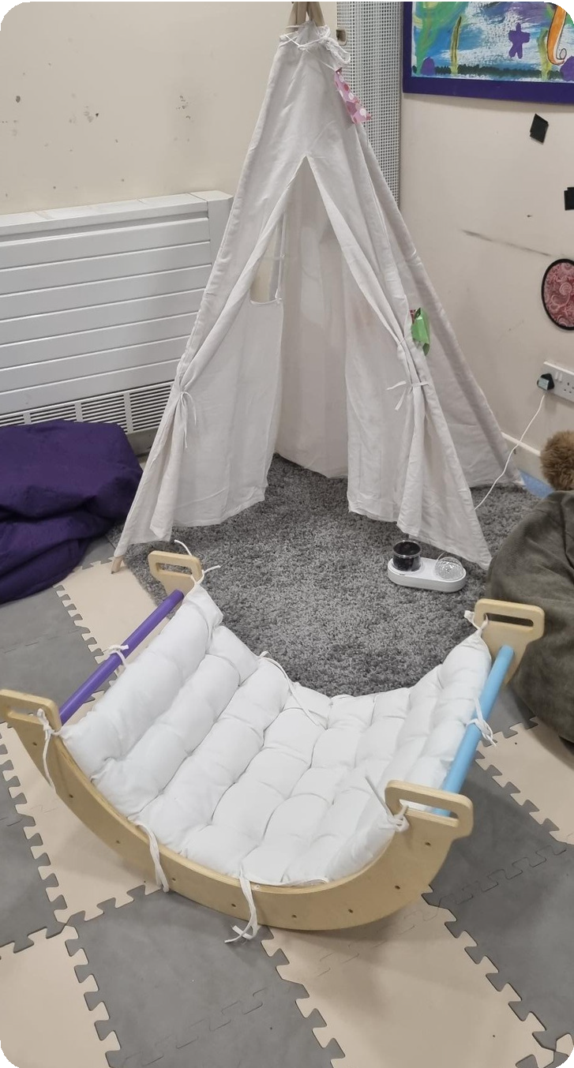
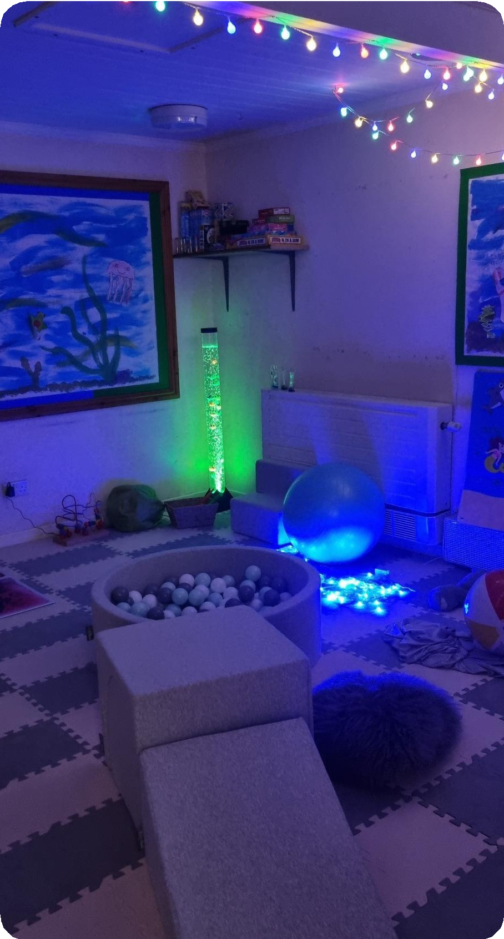
Sensory room
New for 2024! St
John’s has a brand new sensory room
to
to and
allow
self
children
regulate
use
when
needed.

“Leaders have high
expectations of pupils’ conduct. These are reflected in pupils’ calm behaviour in classrooms, around the school and on the playground. Pupils are polite and well-mannered.
-OFSTED report 2022

PTA
St John’s PTA have a hugely proactive and enthusiastic group of parents & staff who raise funds to support our school. They add enormous value to the sense of community. We are very proud of the many extra opportunities that we for the children.



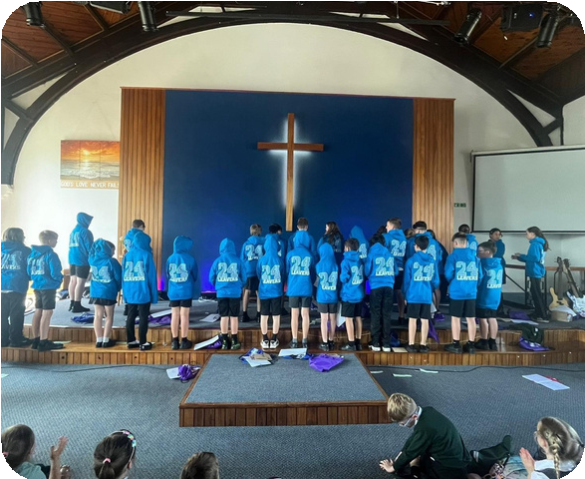


Parental Engagement

Working together between home and school is important to support your child. We love to invite parents in at every opportunity, from our Shining Star Worships to our Learning Together workshops where parents are invited to see how their children learn.



At St John’s we are also here to support
parents in any way we can and will provide advice and access to external resources when needed.

Just pop in and talk to us!

What to do next and how to contact us

Apply to St-Johns C of E Academy via the Gloucestershire County Council Website www.gloucestershire.gov.uk click on the education and learning button on the home page for School Admissions.

Give us a ring on 01594-832046 or email admin@st-johns.dgat.org.uk and arrange to come and visit us.

Follow us on Facebook pages St-Johns C of E Academy
St Johns C of E Academy PTA

Visit our website at www.st-johns- academy .eschools.co.uk/web

Bowen’s Hill Road, Coleford, Gloucestershire GL16 8DU


We cannot wait to see you!

