Thursday 8th May 2025

Dear Parents/Carers

I would like to inform you that Mrs. Kennedy began her maternity leave yesterday, earlier than expected, she had planned to continue working until the end of this term.

From Monday 12th May until the end of the summer term, Beech Class will be covered by Mrs Sian Damon.

Mrs Damon is familiar with the class as she was a cover teacher in Beech Class earlier this year.

If you have any questions, please contact myself via the school office.

Kind Regards

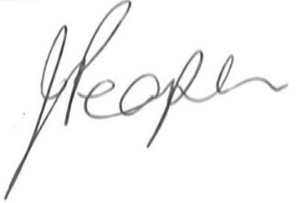

Joanne Peaper

Headteacher