**Year 6 - Climate Change Courageous Advocacy Project**

**Information for parents and carers**

*(The children are very good at looking up the online links!)*

**This project is a partnership between the School and Mid-Wyedean Parish (the Church of England churches which are linked with the school). It has been funded through a County Council “Greener Gloucestershire” grant.**

The idea is to help the children speak up about an issue that impacts not only them directly, but also people in the wider society, particularly those less able to speak up for themselves. This takes its inspiration from the biblical stories of the prophets and of Jesus speaking to those in power about injustice, poverty and suffering. The project aims to build children’s confidence that change is possible and that they can play a part in bringing change.

**What did we learn?**

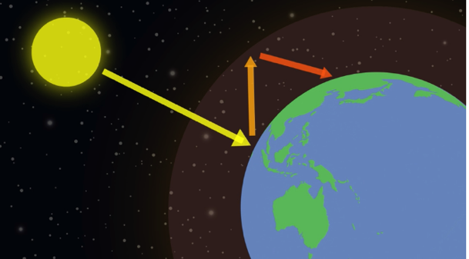First the children learned about the science of climate change. We discussed which sources of information might be most reliable and best adapted for children.

The children researched online, with some guidance. They looked at information from NASA, the United Nations, the UK Met Office, UK charities etc.. We found that the BBC Bitesize videos give clear and short explanations of the main issues:

**Climate Change:** <https://www.bbc.co.uk/bitesize/articles/zcjk7v4#z8mj6rd>

**Global Climate Change:** (from 1’45” on) <https://www.bbc.co.uk/bitesize/articles/ztx9qyc>

**Fossil Fuels:** <https://www.bbc.co.uk/bitesize/articles/zc69r2p#zt8bdnb>

We noticed that they only referred to Scotland and Wales and discovered that climate change is not on the compulsory English primary curriculum.

**Other sources:**

NASA: <https://climatekids.nasa.gov/climate-change-evidence/>

Met Office: <https://www.metoffice.gov.uk/weather/climate-change/what-is-climate-change>

United Nations: <https://www.un.org/en/climatechange/science/mythbusters>

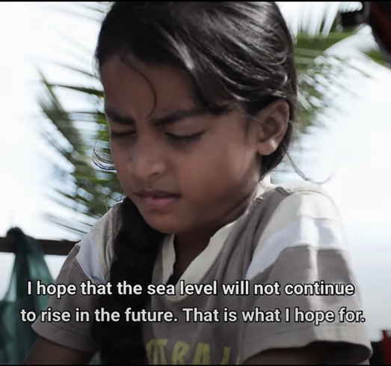The Royal Society: <https://royalsociety.org/news-resources/projects/climate-change-evidence-causes/>

We also thought about the impacts of climate change, for example as shown in this video from UNICEF <https://youtu.be/AfzFH5bPdU4?si=3UqeAF_v-f9CXpGr>

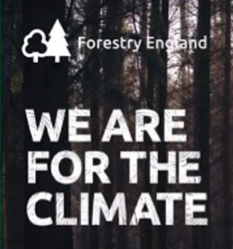**Visitors:** We had a visit from Forestry England and were able to ask about what they do to help tackle climate change. We also had a visit from the Forest of Dean District Council Cabinet member responsible for Climate Change Action.

**The link to RE and Christian faith**

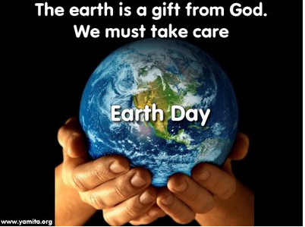We did not have time to discuss this, but there are three clear links between tackling climate change and Christian belief (most other religions have similar alignment).

a) Christians see the earth and creation as a gift from God, we need to treat that gift with respect and care for our planet and for nature.

b) The Bible teaches that we should “love our neighbour”. Jesus made clear that this includes people from different places and of different faiths - anyone in the world and particularly those who are most vulnerable (including those not yet born). We know that climate change is already having a disproportionate impact on those who have the least.

c) The advertising industry tries us to convince us that buying new things all the time will make us happy, when often it puts us under more stress. The Bible teaches that loving things (our possessions) and wanting more, is not the route to happiness and a good life.

**Action**

The UK has benefited hugely from burning fossil fuels. We were way ahead of other countries in the 19th Century, creating bricks, iron and steel to build much our infrastructure. Carbon emissions per head in China have only gone above the UK in the last decade. India’s are still far lower. There is therefore a strong case for UK going first in reducing carbon emissions.

**What can be done?:**

Save the Children Fund: <https://www.youtube.com/watch?v=bMEaxzkDFNw> (12 mins long but worth watching)

The children have created their own videos about various aspects of climate change:

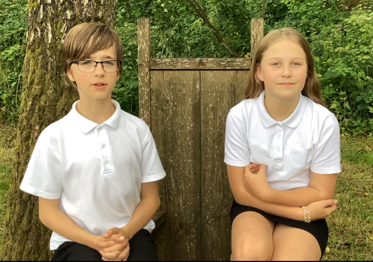<https://st-johns-academy.eschools.co.uk/web/courageous_advocacy/692671>

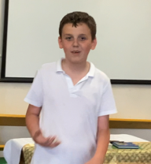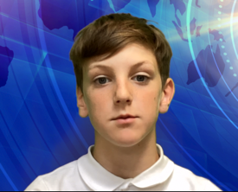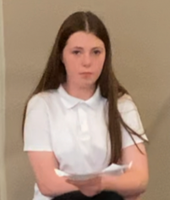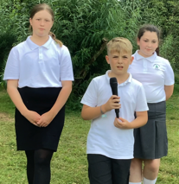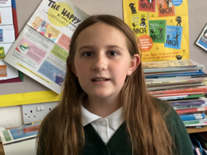

And recorded and sent a question to our new MP and Government (last video).

Reducing damaging climate change needs action at all levels, international, national and local government, businesses and households.

**Some practical actions for families:**

**Waste:** We discovered that while recycling is important, it is not the best option.

**Prevent -** do we even need the thing in the first place? e.g. plastic wrappings on bananas or plastic toys 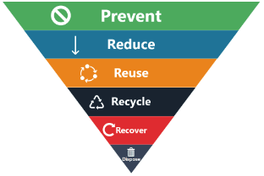that only last a few weeks, or clothes we only wear once.

**Reduce** - Can we be more careful to only buy the amount of food we need and avoid throwing away gone off food? Can we have fewer presents at Christmas and birthdays (but maybe better quality things that last).

**Reuse** - buying second hand clothes, borrowing tools rather than buying things we don’t use very often, selling or donating things we don’t need.

**Repairing** things rather than just buying new; finding new uses for things we no longer need.

**Contacts and ideas:**

Appliance repairs (Yorkley): <http://baldwinsappliances.co.uk/> 07734 823241

Shoe Repairs (Regent St. Lydney) 01594 842097

Monthly Repair Cafés in Yorkley, Ruspidge and Monmouth (free).

Forest Friendly shop (Lydney) refill foods, cleaning etc. <https://www.forestfriendly.co.uk/>

Monmouth Library of things (Bridges Centre) <https://monmouthshire.benthyg.cymru/>

Forest of Dean Baby Bank <https://forestbabybank.org/> (drop of point 40 Boxbush Rd.)

Forest Upcycling Project <https://forestupcyclingproject.com/>

Find out what to do with your waste: <https://www.gloucestershirerecycles.com/>

**Cooking** Eating food in season, batch cooking, and freezing rather than buying ready meals, eating less meat and more veg - but local good quality.

**Gardens** Growing our own is healthy and fun.Composting and using a no dig approach keeps the carbon in the soil, helps things grow better and reduces the need to water and to buy plant food. <https://www.youtube.com/watch?v=0LH6-w57Slw>

Using water butts - Smith’s in Milkwall sell really long lasting ones reusing industrial containers - <https://smithsofthedean.co.uk/product/recycled-plastic-drum-220-litres/>

**Transport:** Walking, of cycling rather than taking the car - (this has to be balanced with road safety and the time involved but it does save a lot of energy and cash!). Using public transport where possible (and campaigning for better public transport!).

**Home energy** - shutting doors, closing curtains, turning the heat down and putting on another layer (you can remind your children that they all thought these were good things to do!) Warm and Well (household income under £36K) <https://warmandwell.co.uk/>

There are various Government grants for decarbonising heating systems but they have been a bit of a muddle and are changing with the new Government. The following sites should have information: <https://www.fdean.gov.uk/environment/climate-action/climate-action-you-can-take/>

There is a lot of good information here: <https://www.cse.org.uk/my-home/advice/>

**Many of these things are going back to the wisdom of older generations!**

***If we get any replies to the children’s question on teaching climate change in primary schools we will post it on the school website with the videos.***

**Mark Bick July 2024.**

**You are welcome to contact me with any questions** [**mark@markbick.co.uk**](mailto:mark@markbick.co.uk)

**(particularly questions about gardening - I also help run the school garden).**